ACO Doppelabzweig GM-X DN100x100x100x45 Grad

ACO Haustechnik

Eigenschaften

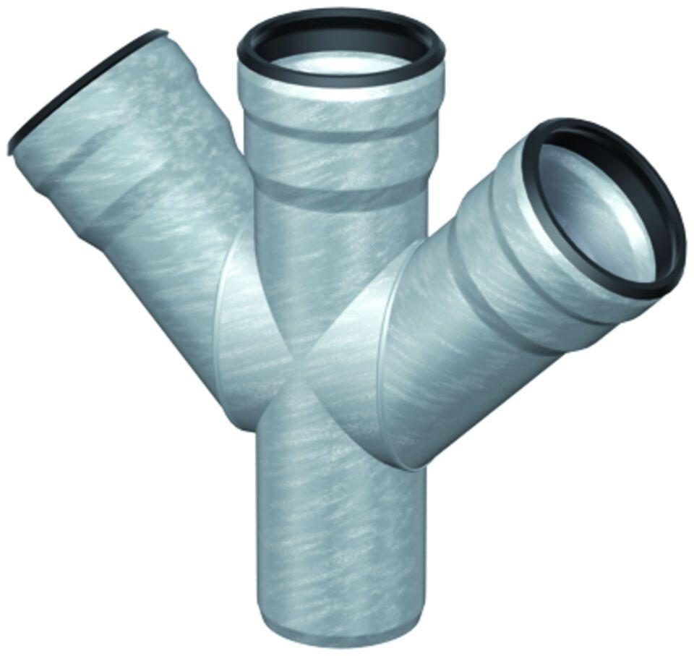

GTIN:

8590830708587

HAN:

0174.13.84