ACO Doppelabzweig Red. GM-X DN150x100x100x45 Grad
ACO Haustechnik

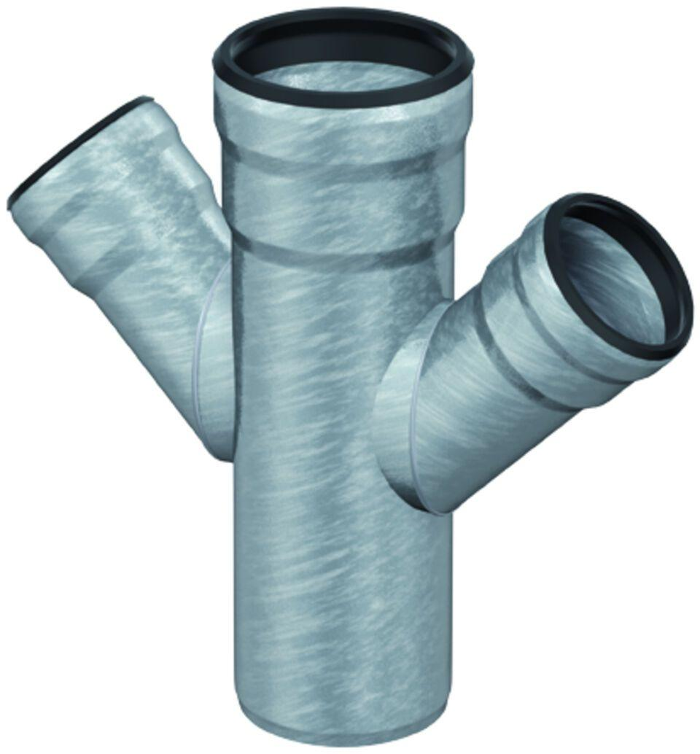Eigenschaften
GTIN:
8590830708648
HAN:
0174.13.87

