ACO Eckdoppelabzweig GM-X DN100x100x100x87 Grad

ACO Haustechnik

Eigenschaften

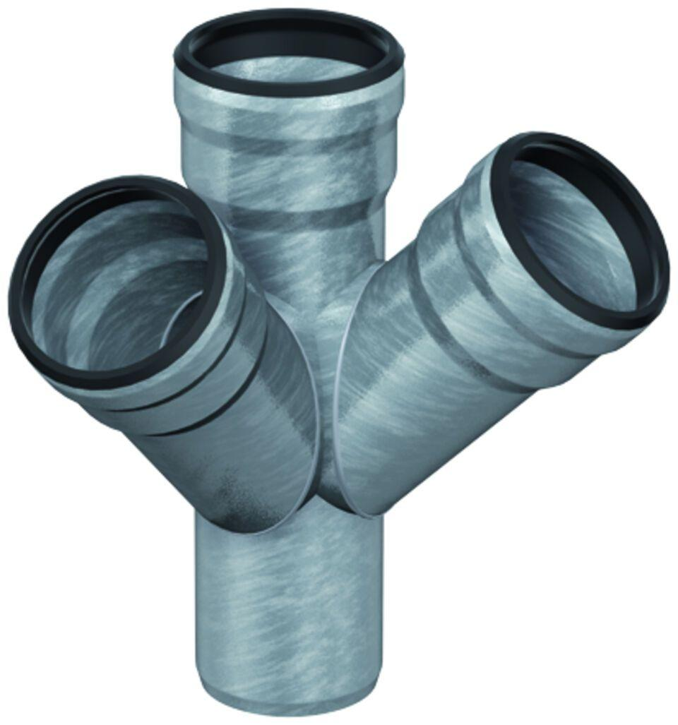

GTIN:

8590830709218

HAN:

0174.14.03