ACO ShowerDrain Rost/grating 1000x80/ Wave/ V2A/ K3
ACO Haustechnik

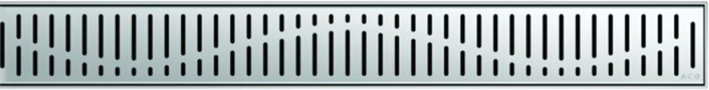Eigenschaften
GTIN:
4002626147455
HAN:
0153.73.45

