Eurasol Max, B = 190 mm, L = 25 m

Adolf Würth

Eigenschaften

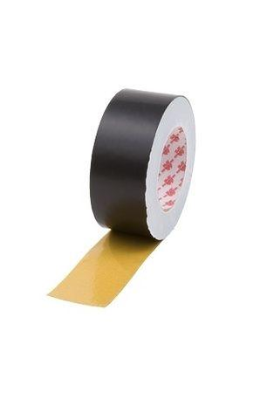

GTIN:

4049557402901

HAN:

0992710161