6716/01 UJ-84 BT-switch, Set, Fut, BJE

Busch-Jaeger

Eigenschaften

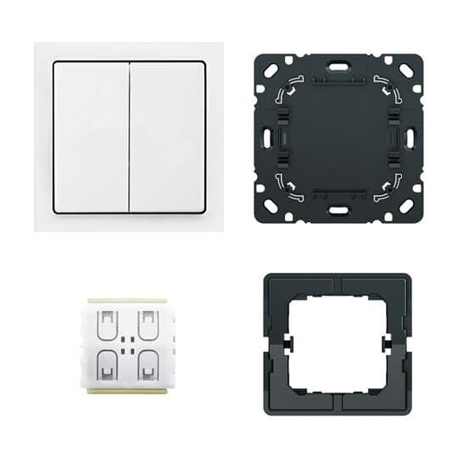

GTIN:

4011395310595

HAN:

2CKA006730A0154