6716/01 UJ-914 BT-switch Set, BSI, BJE

Busch-Jaeger

Eigenschaften

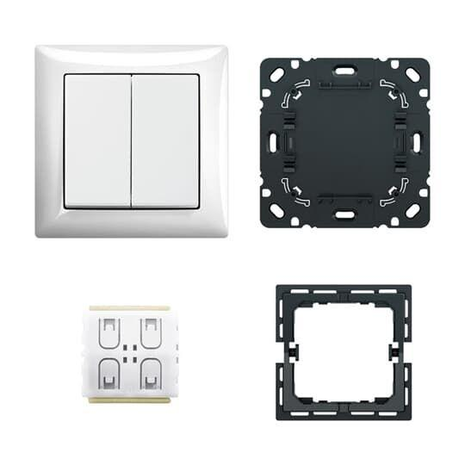

GTIN:

4011395310588

HAN:

2CKA006730A0153