Danfoss Thermostat

DanfossClimate Solutions

Eigenschaften

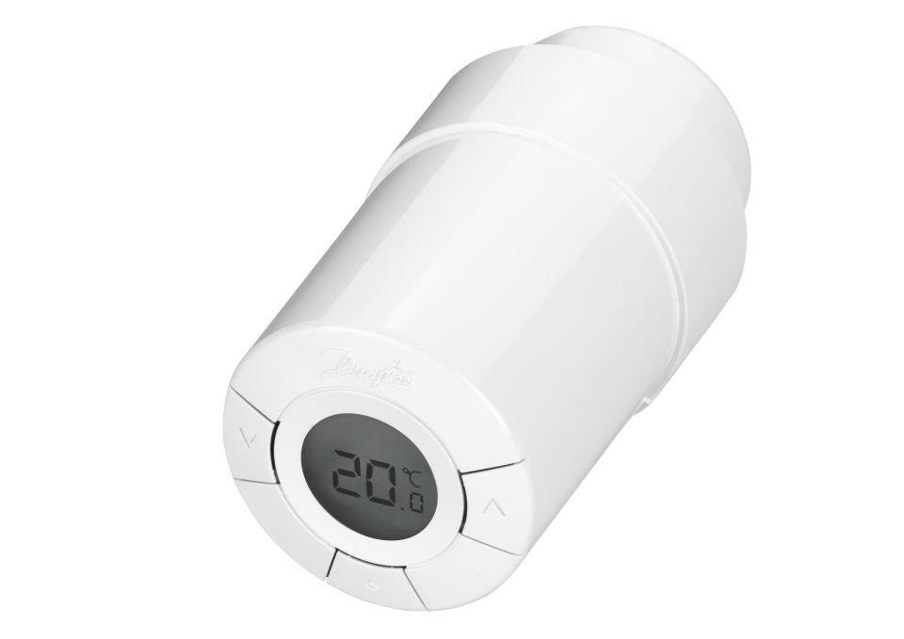

GTIN:

5702420110264

HAN:

014G0002