Danfoss UV Flammensensor

DanfossClimate Solutions

Eigenschaften

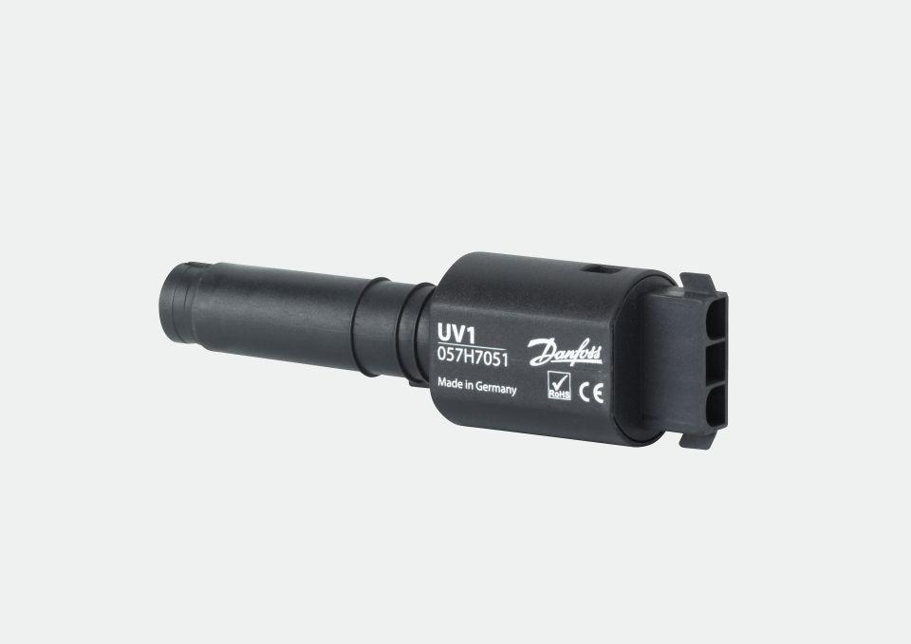

GTIN:

5702425080609

HAN:

057H7051