GE GIS Element f. Wand-WC, 100cm mit Omega UP-SPK 12cm

Geberit

Eigenschaften

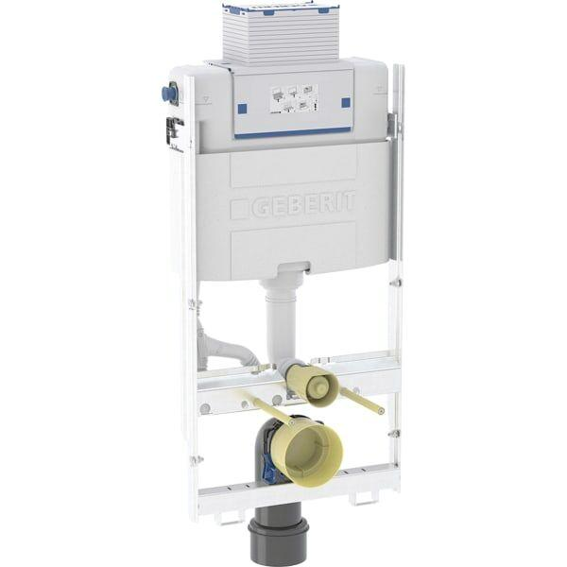

GTIN:

4064746023859

HAN:

461151002

Breite (mm)

424,00

Höhe (mm)

1.000,00

Tiefe (mm)

205,00

Abmessungen Gewindeanschluss Leitungswasser (Inch)

1/2 Zoll

Anschluss

Außengewinde

Material des Spülkastens

Kunststoff

Qualitätsklasse Spülreservoir

Polyethylen (PE)

Äußerer Rohrdurchmesser Spülrohr (mm)

45,00

min. Ablagenhöhe (mm)

1.000,00

Suitable for drywall

false

Suitable for solid wall

false

Suitable for sanitary installation wall system

true

Suitable for flushing flow throttling

true

Suitable for toilets with a reduced contact area

false

Centre distance of toilet attachment

18 cm und 23 cm

Suitable for shower toilet

true

With fan connection

false

With electrical connection

false

Number of tap water connections

1

Load capacity >= 400 kg according to EN 997

false

With front cladding

false

Outer pipe diameter drainage

90 mm

With delayed filling process

false

With maintenance opening

true