GROHE Carbon-Filter GROHE Blue 40547_1 BWT-Austauschfilter
GROHE

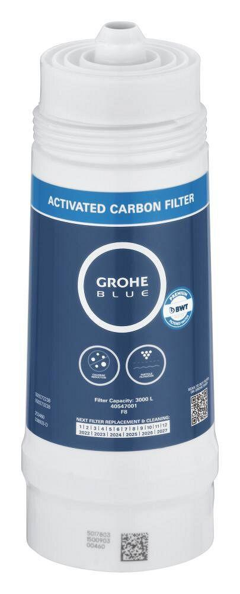Eigenschaften
HAN:
40547001
Art des Zubehörs
Filter
Accessory
true
Spare part
false
Filter capacity
3000
Water softening
false
Mineralization
false

