GROHE Spülen-Ablaufgarnitur 40997 1 Becken ohne Exzenter cool sunrise gebürstet
GROHE

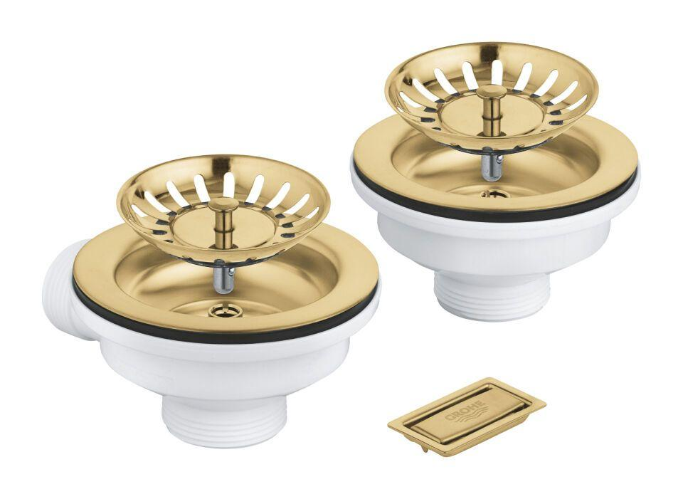Eigenschaften
HAN:
40997GN0
Nenninnendurchmesser Auslass
Sonstige
With basket sieve (strainer)
true
With lifting gear
false
With drain plug
true
With lifting rod
false
Suitable for kitchen sink
true
Suitable for shower tray
false
Colour upper part
Sonstige
Pop-up model (click-clack)
false

