GROHE Spülen-Ablaufgrt. 40997 1 Becken ohne Exzenter cool sunrise gebürstet

GROHE

Eigenschaften

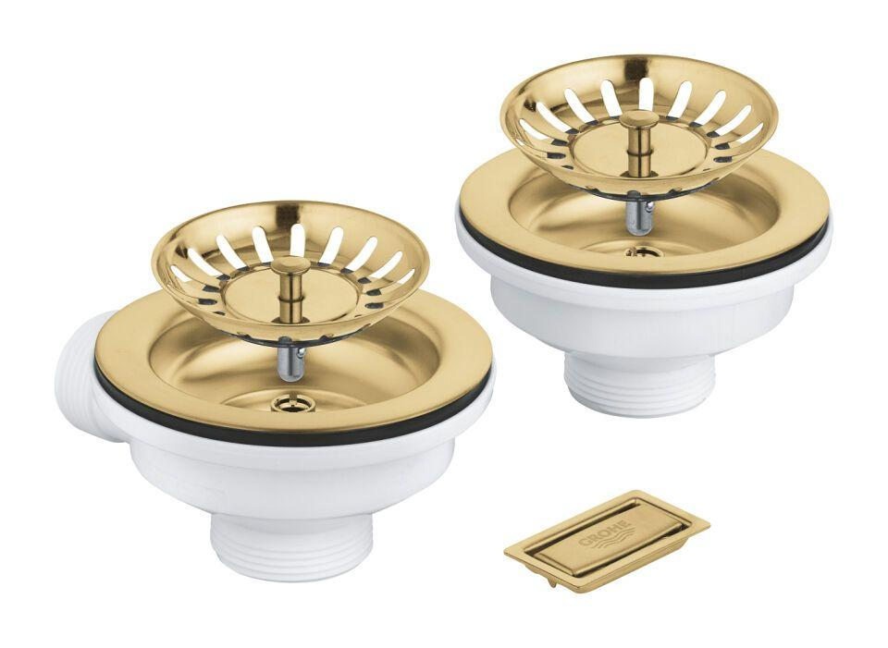

HAN:

40997GN0

Nenninnendurchmesser Auslass

Sonstige

With basket sieve (strainer)

true

With lifting gear

false

With drain plug

true

With lifting rod

false

Suitable for kitchen sink

true

Suitable for shower tray

false

Colour upper part

Sonstige

Pop-up model (click-clack)

false