GROHE WAS Eckfix

GROHE

Eigenschaften

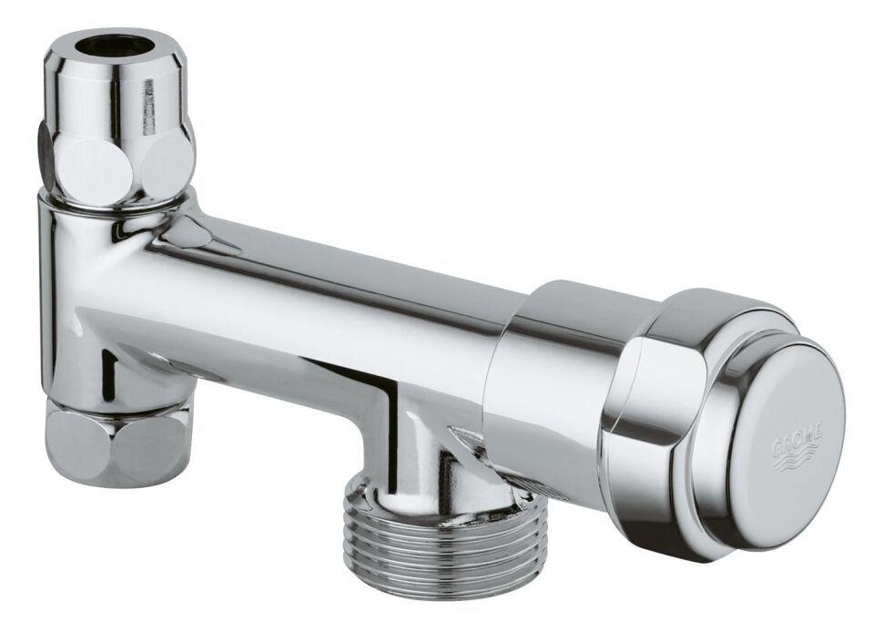

HAN:

41031000

Farbton

chrom

Werkstoff

Messing

KIWA certified

false

Type approval according to BBR/EKS

false