IMI PNEUMATEX Abscheider Zeparo Cyclone Dirt und Magnetit ZCDM Set 20

IMI Hydronic Engineering Deutschland

Eigenschaften

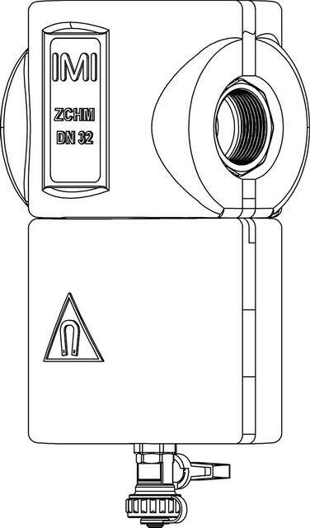

GTIN:

7640153570598

HAN:

7897520

Whirl operating principle

true

Magnet operating principle

true