IMI PNEUMATEX Abscheider Zeparo Cyclone Dirt und Magnetit ZCDM Set 25

IMI Hydronic Engineering Deutschland

Eigenschaften

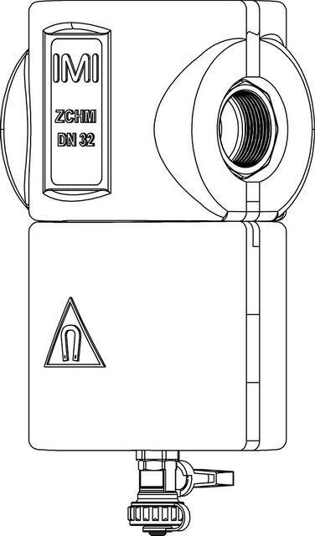

GTIN:

7640153570604

HAN:

7897525

Whirl operating principle

true

Magnet operating principle

true