IMI PNEUMATEX Abscheider Zeparo Cyclone Dirt und Magnetit ZCDM Set 32

IMI Hydronic Engineering Deutschland

Eigenschaften

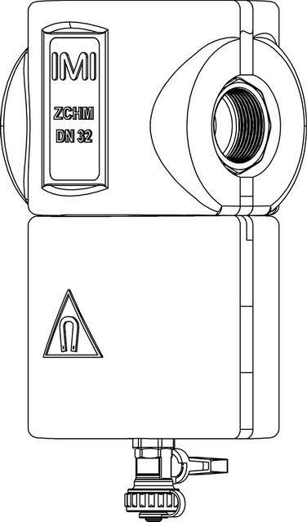

GTIN:

7640153570611

HAN:

7897532

Whirl operating principle

true

Magnet operating principle

true