IMI PNEUMATEX Abscheider Zeparo Cyclone Dirt und Magnetit ZCDM Set 40

IMI Hydronic Engineering Deutschland

Eigenschaften

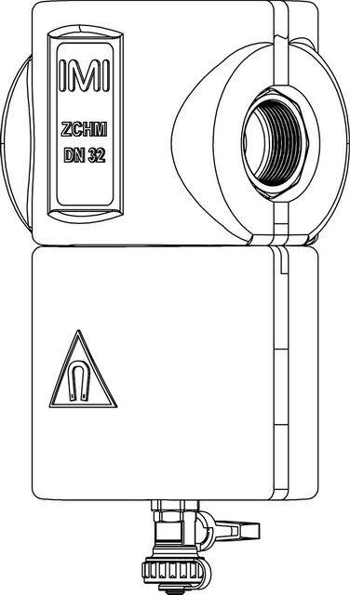

GTIN:

7640153570628

HAN:

7897540

Whirl operating principle

true

Magnet operating principle

true