IMI PNEUMATEX Abscheider Zeparo Cyclone Dirt und Magnetit ZCDM Set 50

IMI Hydronic Engineering Deutschland

Eigenschaften

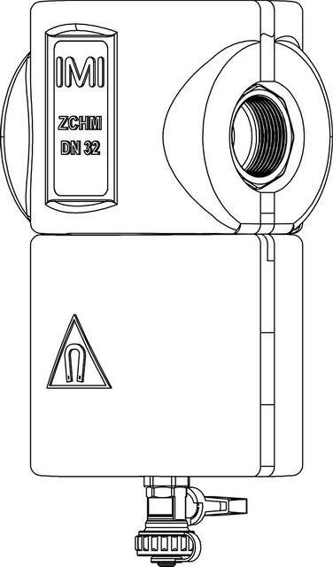

GTIN:

7640153570635

HAN:

7897550

Whirl operating principle

true

Magnet operating principle

true