Ankerstange HB - VMZ - A 125 16- 60/ 210 A4
Leviat

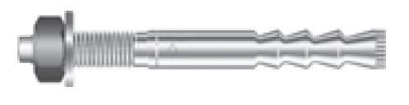Eigenschaften
HAN:
0432.380-00119

