PREFA Sailerklemme LALO bronze 45 Bronze
PREFA

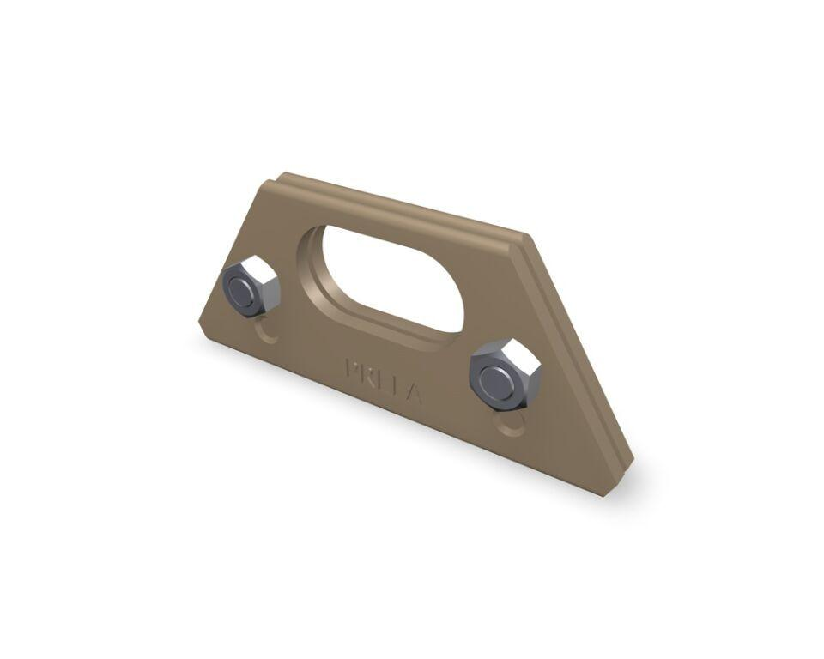Eigenschaften
GTIN:
4043111126272
HAN:
121123

