PREFA Sailerklemme LALO P.10 anthraz 02 P.10 Anthrazit
PREFA

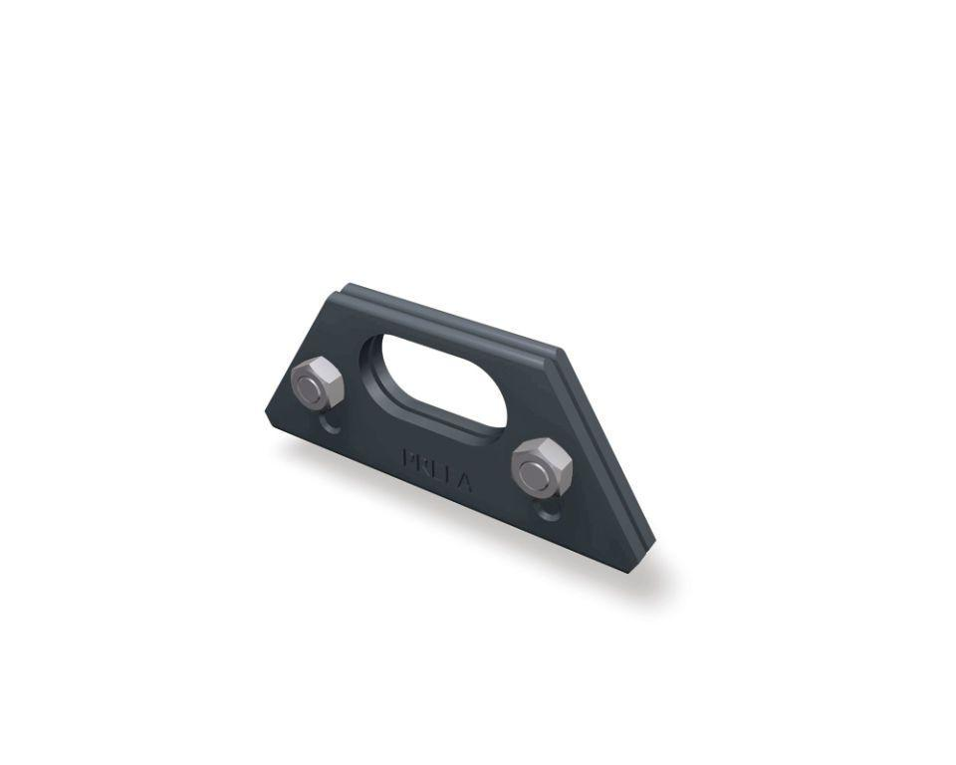Eigenschaften
GTIN:
4043111032894
HAN:
120220

