PREFA Sailerklemme Langloch
PREFA

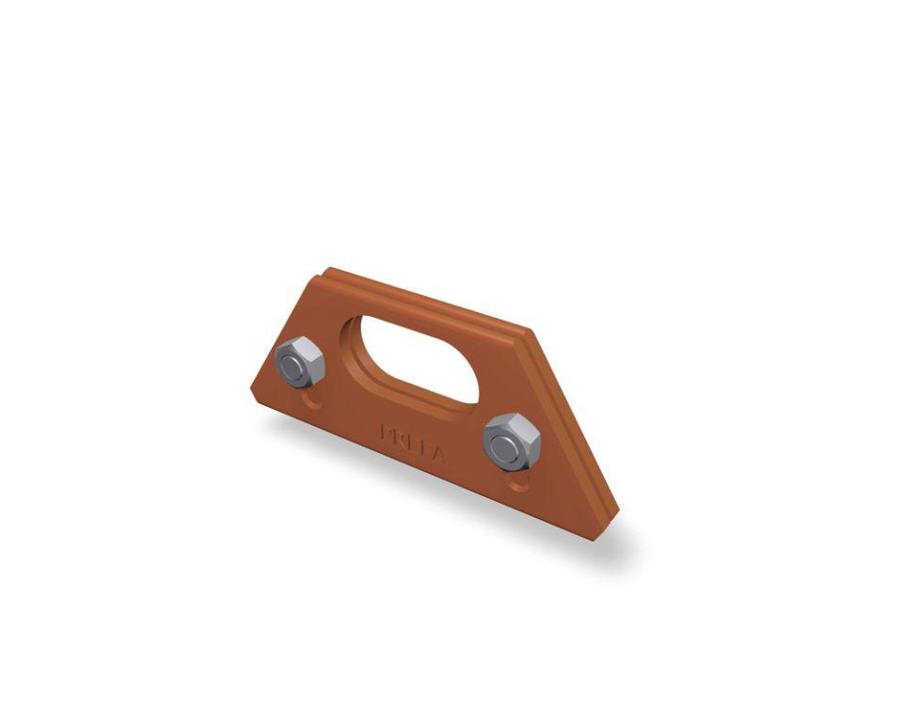Eigenschaften

