PREFA Sailerklemme
PREFA

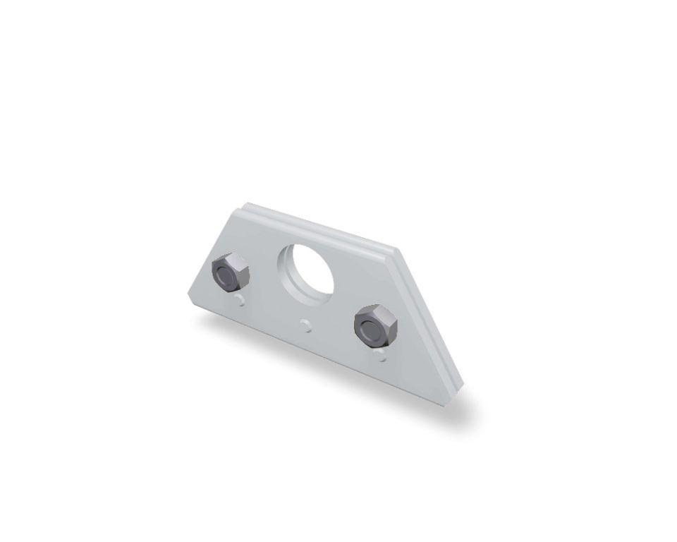Eigenschaften

