weber.star 223 AquaBalance 2,0mm, 25kg/Sack 10

Saint-Gobain Weber

Eigenschaften

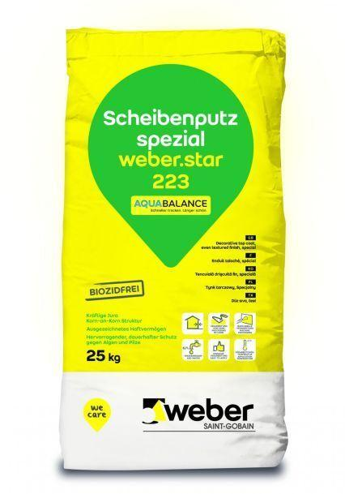

GTIN:

4011361009690

HAN:

384703