weber.star 223 AquaBalance 2,0mm, 25kg/Sack 1895

Saint-Gobain Weber

Eigenschaften

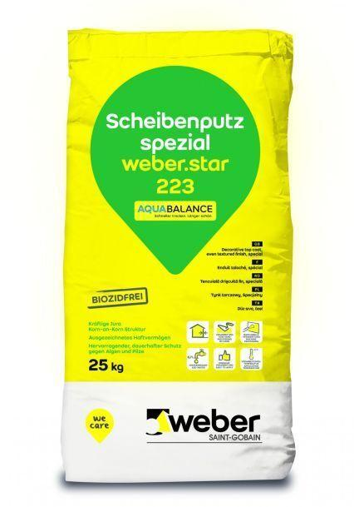

GTIN:

4011361043649

HAN:

401057