weber.star 223 AquaBalance 2,0mm, 25kg/Sack 30024

Saint-Gobain Weber

Eigenschaften

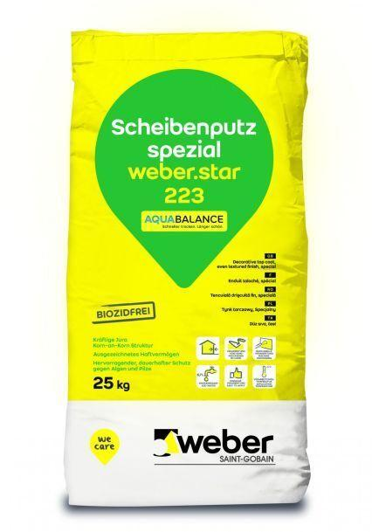

GTIN:

4011361038065

HAN:

394771