weber.star 223 AquaBalance 2,0mm, 25kg/Sack 30036
Saint-Gobain Weber

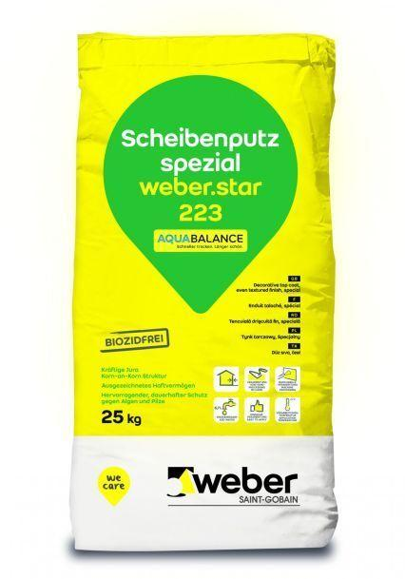Eigenschaften
GTIN:
4011361039680
HAN:
396098

