weber.star 223 AquaBalance 2,0mm, 25kg/Sack 30046
Saint-Gobain Weber

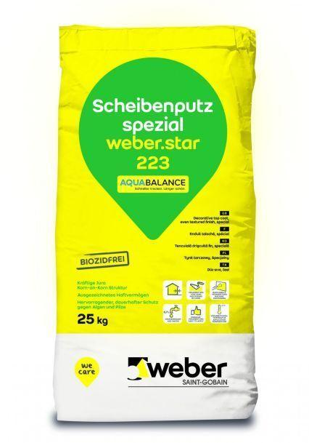Eigenschaften
GTIN:
4011361011143
HAN:
382580

