weber.star 223 AquaBalance 2,0mm, 25kg/Sack 30063
Saint-Gobain Weber

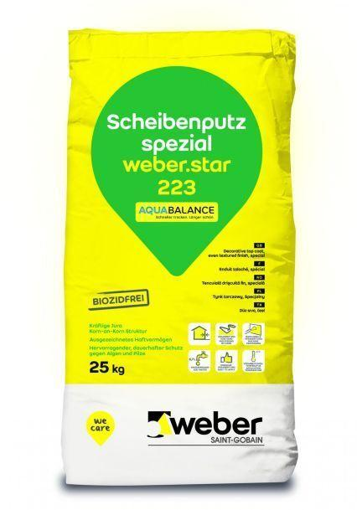Eigenschaften
GTIN:
4011361037228
HAN:
394061

