weber.star 224 AquaBalance 1,5mm, 25kg/Sack 10
Saint-Gobain Weber

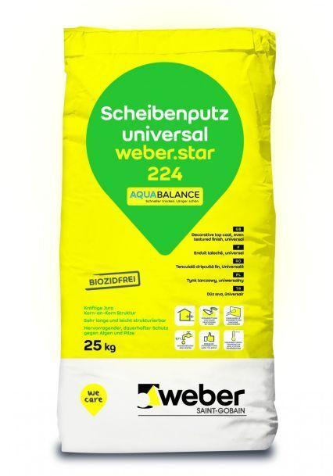Eigenschaften
GTIN:
4011361188715
HAN:
381951

