weber.star 224 AquaBalance 1,5mm, 25kg/Sack 30021
Saint-Gobain Weber

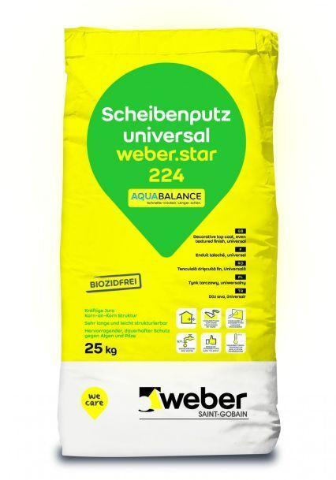Eigenschaften
GTIN:
4011361017008
HAN:
383858

