weber.star 224 AquaBalance 1,5mm, 25kg/Sack 30032
Saint-Gobain Weber

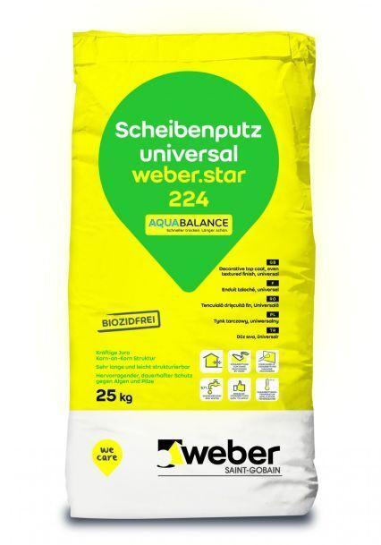Eigenschaften
GTIN:
4011361018814
HAN:
384209

