weber.star 224 AquaBalance 1,5mm, 25kg/Sack 30033
Saint-Gobain Weber

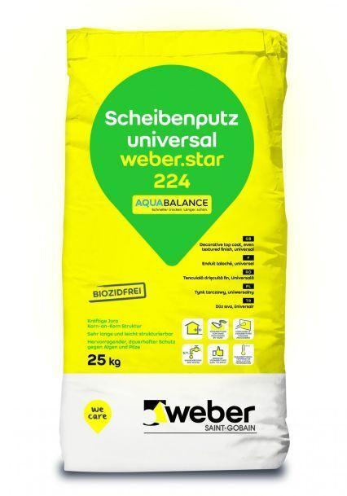Eigenschaften
GTIN:
4011361038386
HAN:
395056

