weber.star 224 AquaBalance 1,5mm, 25kg/Sack 30034
Saint-Gobain Weber

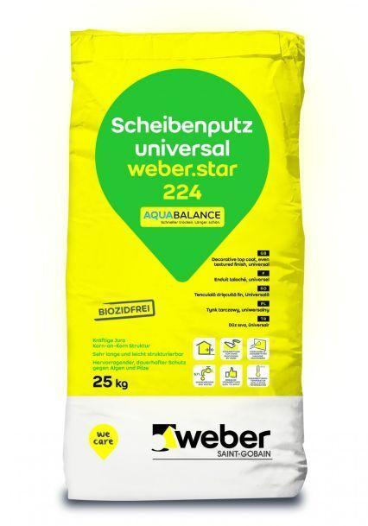Eigenschaften
GTIN:
4011361020992
HAN:
385369

