weber.star 224 AquaBalance 1,5mm, 25kg/Sack 30036
Saint-Gobain Weber

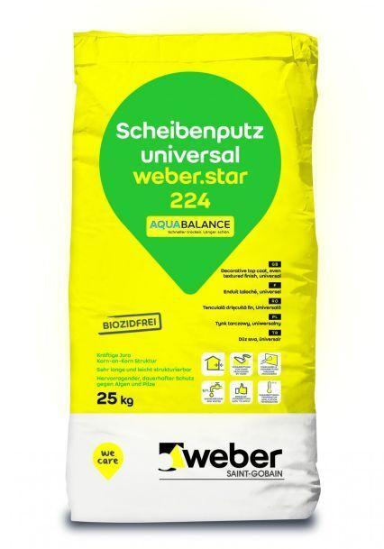Eigenschaften
GTIN:
4011361037051
HAN:
393934

