weber.star 224 AquaBalance 1,5mm, 25kg/Sack 30044
Saint-Gobain Weber

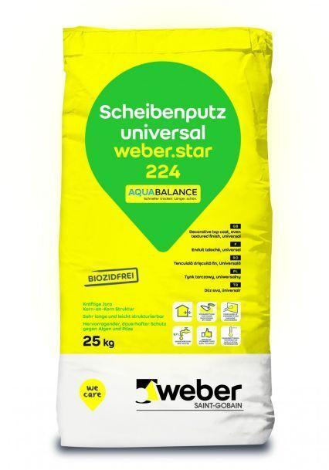Eigenschaften
GTIN:
4011361037105
HAN:
393955

