weber.star 224 AquaBalance 1,5mm, 25kg/Sack 30046
Saint-Gobain Weber

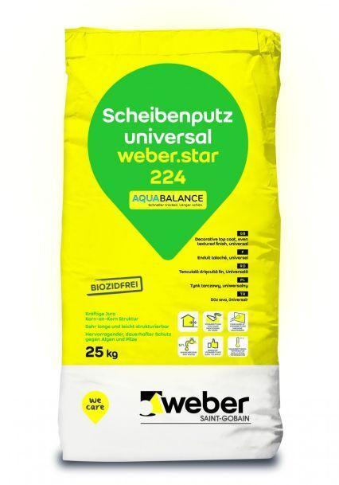Eigenschaften
GTIN:
4011361023481
HAN:
387260

