weber.star 224 AquaBalance 1,5mm, 25kg/Sack 30096
Saint-Gobain Weber

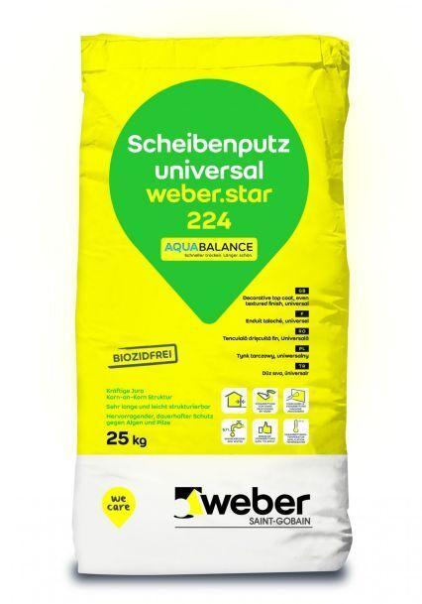Eigenschaften
GTIN:
4011361035880
HAN:
392982

