weber.star 224 AquaBalance 3,0mm, 25kg/Sack 30054

Saint-Gobain Weber

Eigenschaften

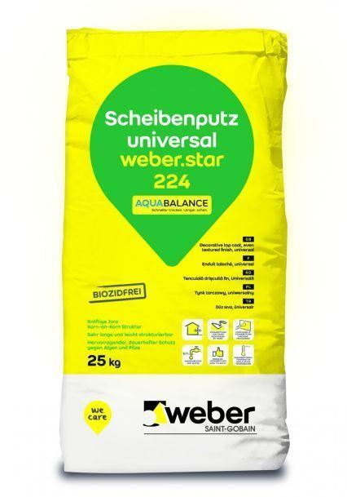

GTIN:

4011361035743

HAN:

392826