weber.star 249 AquaBalance 8,0mm, 25kg/Sack 10

Saint-Gobain Weber

Eigenschaften

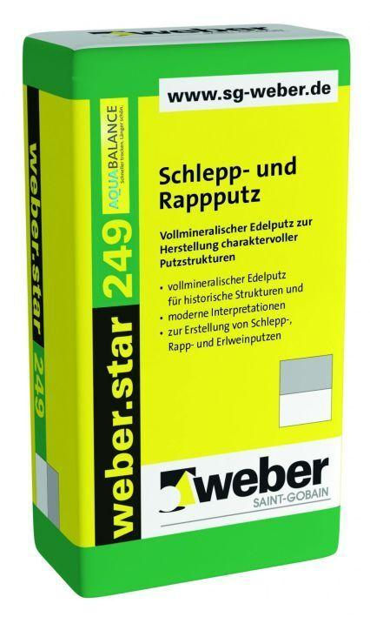

GTIN:

4011361189392

HAN:

383385