weber.star 249 AquaBalance 8,0mm, 25kg/Sack 30

Saint-Gobain Weber

Eigenschaften

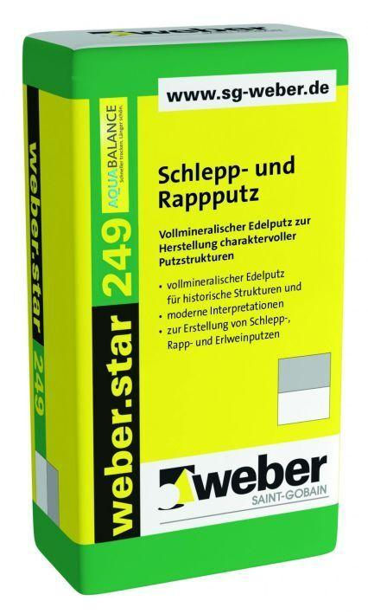

GTIN:

4011361009812

HAN:

387073