weber.star 249 AquaBalance 8,0mm, 25kg/Sack 30223

Saint-Gobain Weber

Eigenschaften

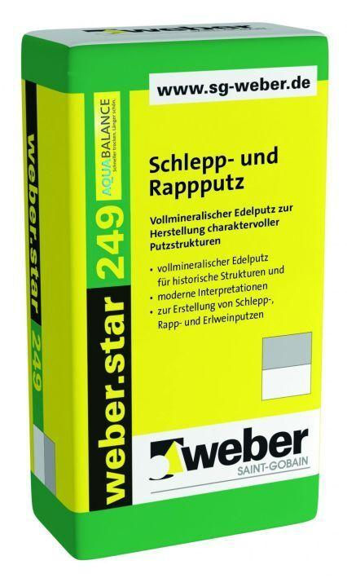

GTIN:

4011361044011

HAN:

401733