BIG BAG GEOMATERIALS 2 m³
SCHLÜSSELBAUER Geomaterials

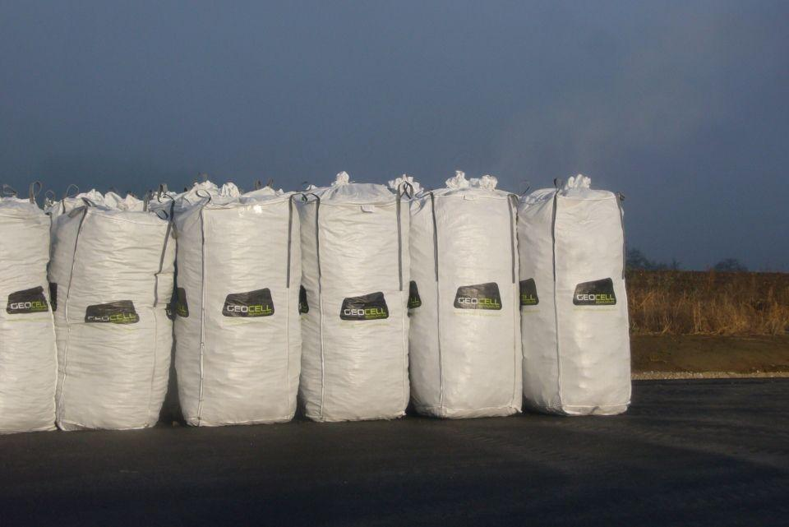Eigenschaften
GTIN:
4260353260032
HAN:
03

