SitaDSS Multi Airstop

Sita Bauelemente

Eigenschaften

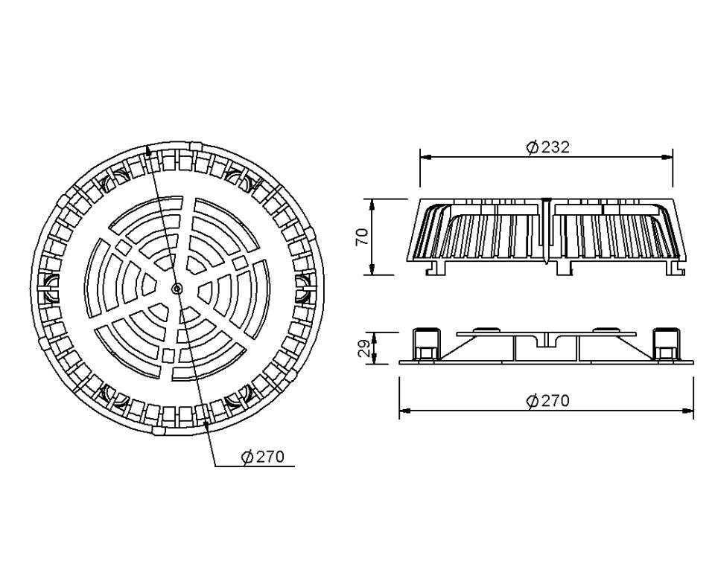

GTIN:

4027563016039

HAN:

139000

Art Zubehör

Airstop