Fassadenverkleidung TRESPA® Meteon® Uni Colours

Trespa Deutschland

Eigenschaften

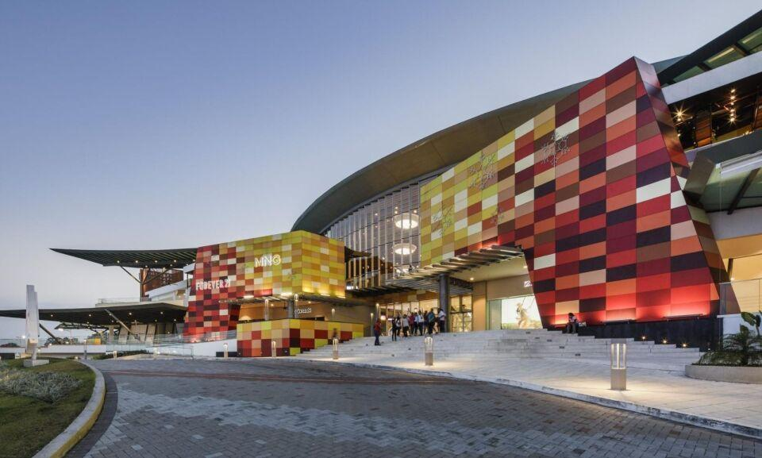

Farbton

beige, blau, braun, dunkelblau, dunkelbraun, dunkelgrau, gelb, grau, grün, hellbeige, hellblau, hellgelb, hellgrau, ocker, orange, rosa, rot, schwarz, silber, violett, weiß

Oberfläche

seidenmatt, strukturiert

Werkstoff

High Pressure Laminate (HPL)

Breite (mm)

1.530,00 - 2.130,00

Länge (mm)

2.550,00 - 4.270,00

Stärke (mm)

6,00 - 13,00

Brandverhalten

B-s1, d0, D-s2, d0

Farbtonbezeichnung Hersteller

A10.4.5 Sienna Brown, A21.1.0 Winter Grey, A04.1.7 Gold Yellow, A10.6.1 Taupe, A08.2.1 Mid Beige, A32.7.2 Dark Green, A23.0.4 Mineral Blue, A07.1.1 Sand, A32.2.1 Translucent Green, A08.4.5 Rusty Red, A08.2.3 Salmon, A25.8.1 Anthracite Grey, A04.0.0 Cream White, A05.1.1 Stone Beige, A03.4.0 Silver Grey, A36.3.5 Turf Green, A04.0.2 Pale Yellow, A09.6.4 Mahogany Red, A03.1.0 Pastel Grey, A06.3.5 Ochre, A22.6.2 Dark Denim, A05.0.0 Pure White, A34.8.1 Forest Green, A11.4.4 English Red, A24.4.1 Steel Blue, A19.7.1 Charcoal Grey, A04.0.1 Pearl Yellow, A03.0.0 White, A11.8.0 Ceramic Greige, A12.2.5 Motion Red, A30.3.2 Verdigris, A08.8.1 Dark Brown, A12.1.8 Passion Red, A06.7.1 Natural Greige, A26.5.4 Pacific, A37.0.8 Lime Green, A12.6.3 Wine Red, A35.4.0 Cactus Green, A21.5.4 Cobalt Blue, A90.0.0 Black, A21.5.1 Mid Grey, A20.5.2 Lavender Blue, A04.0.5 Zinc Yellow, A10.1.8 Red Orange, A31.4.1 Zinc Grey, A12.4.5 East Red, A12.3.7 Carmine Red, A41.0.6 Mojito Green, A22.1.6 Royal Blue, A22.3.1 Ocean Grey, A08.3.1 Stone Grey, A37.2.3 Spring Green, A21.7.0 Steel Grey, A05.1.0 Papyrus White, A20.7.2 Dark Blue, A22.2.1 Bluish Grey, A17.3.5 Cyclam, A05.1.4 Sun Yellow, A22.4.4 Brilliant Blue, A28.6.2 Mid Green, A05.1.2 Champagne, A10.3.4 Terra Cotta, A33.3.6 Brilliant Green, A05.5.0 Quartz Grey, A70.0.0 Slate Grey, A06.5.1 Toscana Greige, A14.7.2 Deep Red Brown, A22.2.4 Powder Blue, A28.2.1 Aquamarine