Lamellendach Lamaxa L50 View
WAREMA Renkhoff

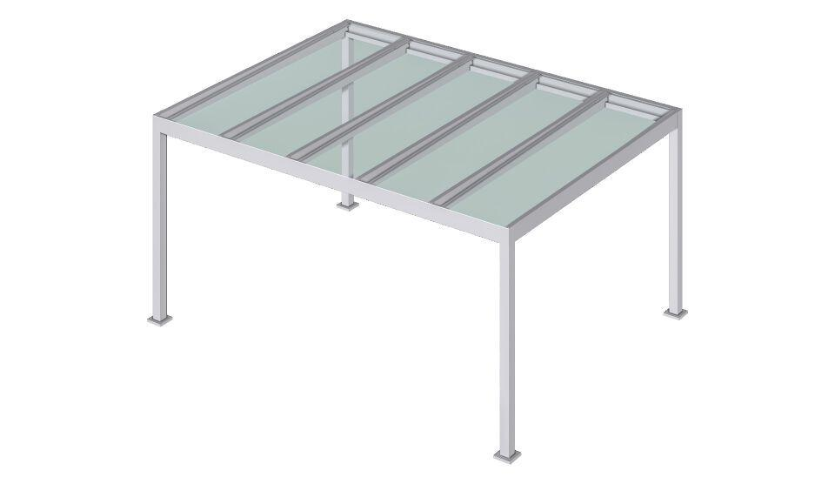Eigenschaften

