POROTON PLAN-T 17,5-1,2 EB 20-1,2 / 373X175X249 (60 ST/PAL)

wienerberger

Eigenschaften

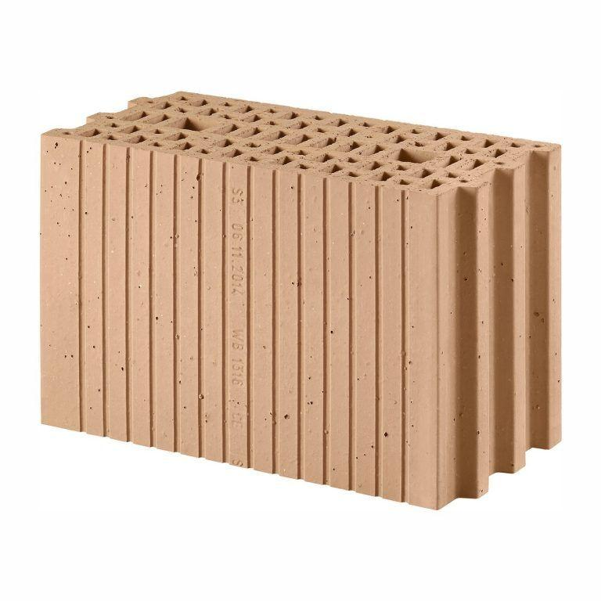

GTIN:

4042351015742

HAN:

3032704